Homework 1

Database Management

Team members: Minghao Du, Han Liu, Yanlin Li

Data: 2/9/2021

Note: Our homework was done in the software called visual paradigm. The UML notation may appear different from the notation used in the lecture.

Part 1:

* A single crime can involve multiple crime charges, such as burglary and assault.
* Criminals can be assigned multiple sentences. For example, a criminal might be required to serve a jail sentence followed by a period of probation.
* Multiple officers may work on a crime, and each officer can be involved in several crimes.
* Crime_dir table means crime defined by the law. One court can charge a criminal with multiple crime defined by the law. The same crime can also be committed by multiple criminals.
* Having a Defense table allows the database to track class action cases. Therefore, this setup can also allow:
  + Criminals to appeal individually regarding specific charge
  + Sentence to associate specific case/crime
  + Each criminal to be prosecuted with partially different set of crimes relative to others who were under the same class action (i.e., A company had committed financial fraud. All executive officers were persecuted with one same charge, and some of them were also persecuted with different additional charges)

Part 2:

1. An online retailer of coffee beans maintains a long list of unique coffee flavors. The company purchases beans from a number of suppliers; however, each flavor of coffee (each product) is purchased from only a single supplier. Many of the customers are repeat purchasers and typically order at least five flavors of beans in each order.

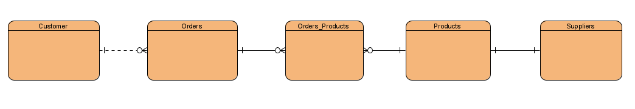

1. Data for an information technology conference needs to be collected. The conference has a variety of sessions scheduled over a two-day period. All attendees must register for the sessions they plan to attend. Some speakers are presenting only one session, whereas others are handling multiple sessions. Each session has only one speaker.

